Plastic Control Box Assembly

# Constant Current Signal Conditioner Wiring

The constant current signal conditioner (CCSC) is a necessary component that provides PCB Piezotronics sensors with the voltage levels they need (known as excitation voltage) to output a useable signal. Figure 1 below is the formal wiring diagram that PCB Piezotronics provides in their documentation, which can be found here: [PCB-G0001G_Lowres.pdf](https://www.pcb.com/contentstore/mktgcontent/linkeddocuments/electronics/PCB-G0001G_Lowres.pdf). Specifically, page 9 of this document will provide more background and explanation on Figure 1.

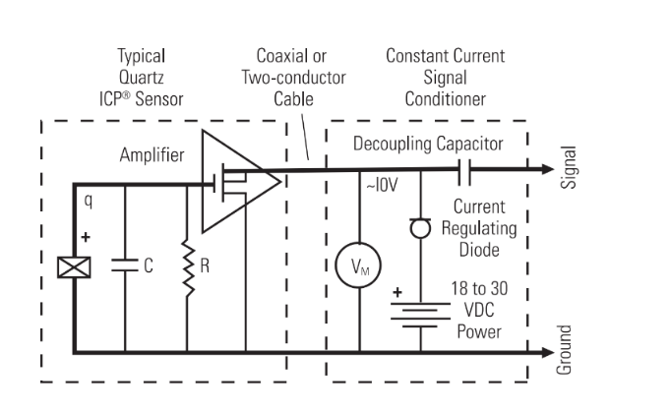

Figure

Figure 2 below is much like Figure 1, they both show that a current regulating diode and standard capacitor are needed to wire up a proper CCSC circuit. Figure 2 just makes the actual wiring connections a bit more comprehensible, and it can be followed directly while ignoring Figure 1. The major difference between the 2 figures is that Figure 1 only shows the wiring for a single PCB Piezotronics sensor, whereas Figure 2 has been slightly modified so that the CCSC can work for 2 sensors.

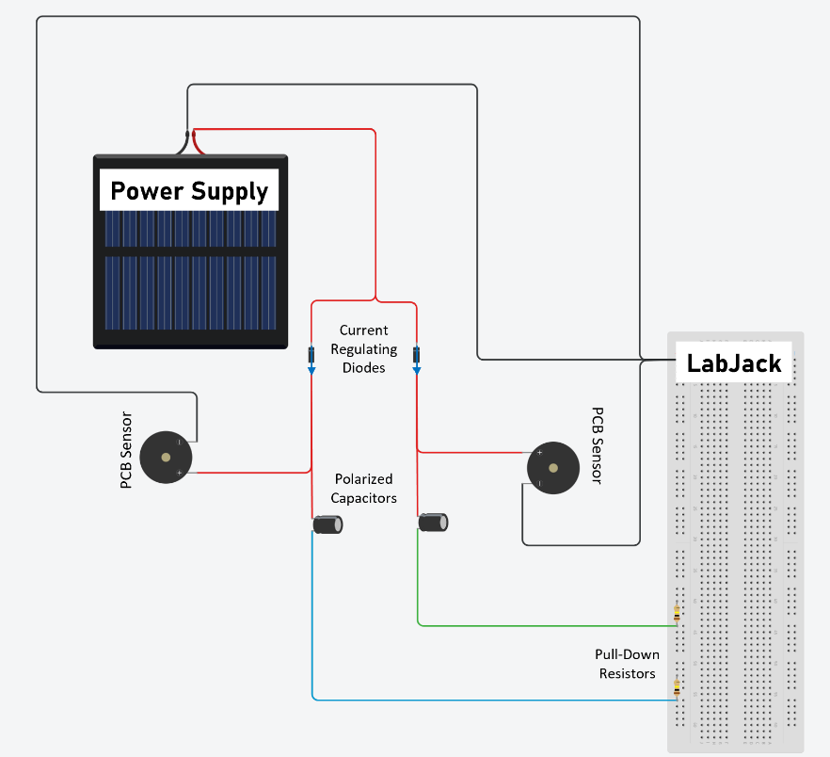

AIN1

AIN0

GND

Figure

Regardless of which figure is used to wire up the CCSC, it is important to double-check the wire connections and make sure that components like diodes or polarized capacitors are facing in the correct orientation before powering on the circuit. The power supply being used will likely be drawing directly from mains voltage, so it is important to exercise caution.

If you are using a power supply that has 3 inputs (ground, neutral, live), make sure you have wired these connections correctly, since the color of wires that correspond to each of these inputs may not follow a coloring convention that is familiar or intuitive to you. For example, live wires are often colored black, even though, from my experience, I would have thought that black wires would be connected directly to ground and consider these to be unpowered.

Once you are certain that the power supply is connected to the circuit properly, you can move on to connecting the CCSC to the LabJack so that the sensors’ readings can be recorded. This is more clearly shown in Figure 2, where the breadboard is actually meant to represent a LabJack. Figure 2 shows that you take one end of a capacitor and connect it to a LabJack analog input (AIN) channel. In Figure 2 there are also pull-down resistors. These resistors have a high resistance value and have one end attached to a ground channel, the other end attached to the AIN channel that signals are being recorded from.

Finally, in Figure 3 below we have a picture of the inside of a previous plastic control box setup. You may use this as a reference image if you wish.

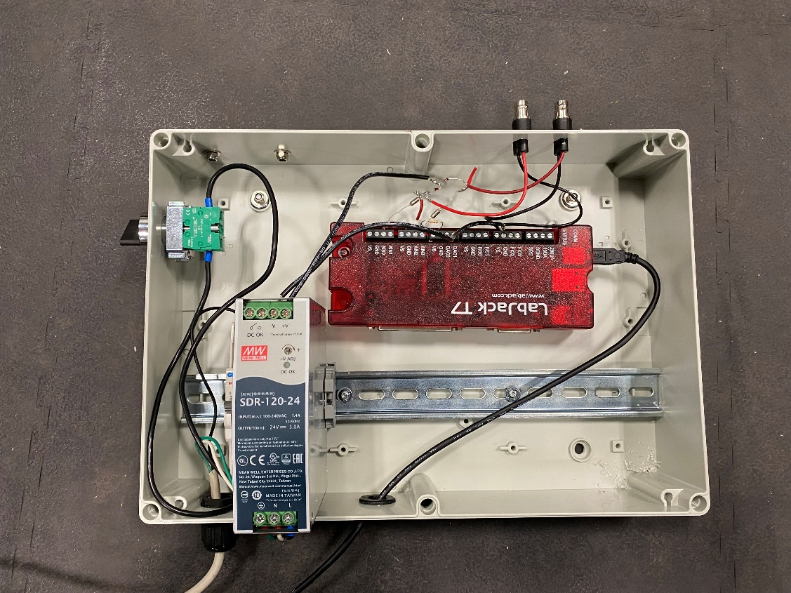

Figure